Aim
To create data visualizations such as bar charts and pie charts for an inventory management system using JavaScript.

Procedure
- Create Project Files
  - Open VS Code
  - Create a folder (e.g., inventory-chart)
  - Add files:
index.html, style.css, script.js
- Add Chart Library
  - Include Chart.js CDN in the HTML file
- Design HTML Structure
  - Create <canvas> elements to display charts
  - Add headings for clarity
- Style Using CSS
  - Center charts on the page
  - Adjust width and layout
- Prepare Inventory Data
  - Define product categories (e.g., Electronics, Clothing, Groceries)
  - Assign stock quantities
- Create Charts Using JavaScript
  - Use Chart.js to create:
    - Bar chart → shows quantity comparison
    - Pie chart → shows percentage distribution
- Run the Program
  - Open index.html in Live Server
  - View charts rendered dynamically

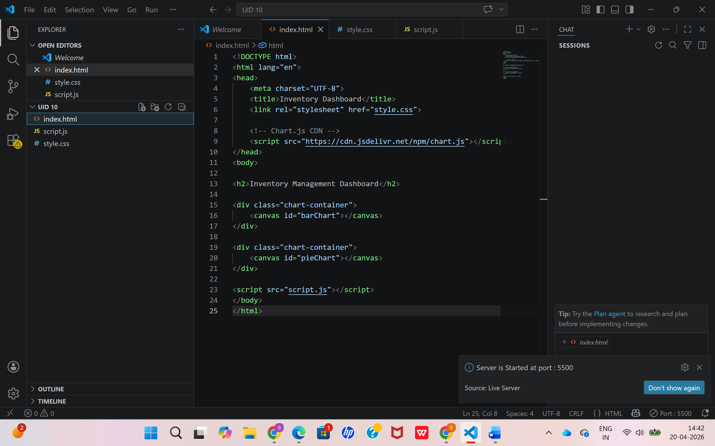

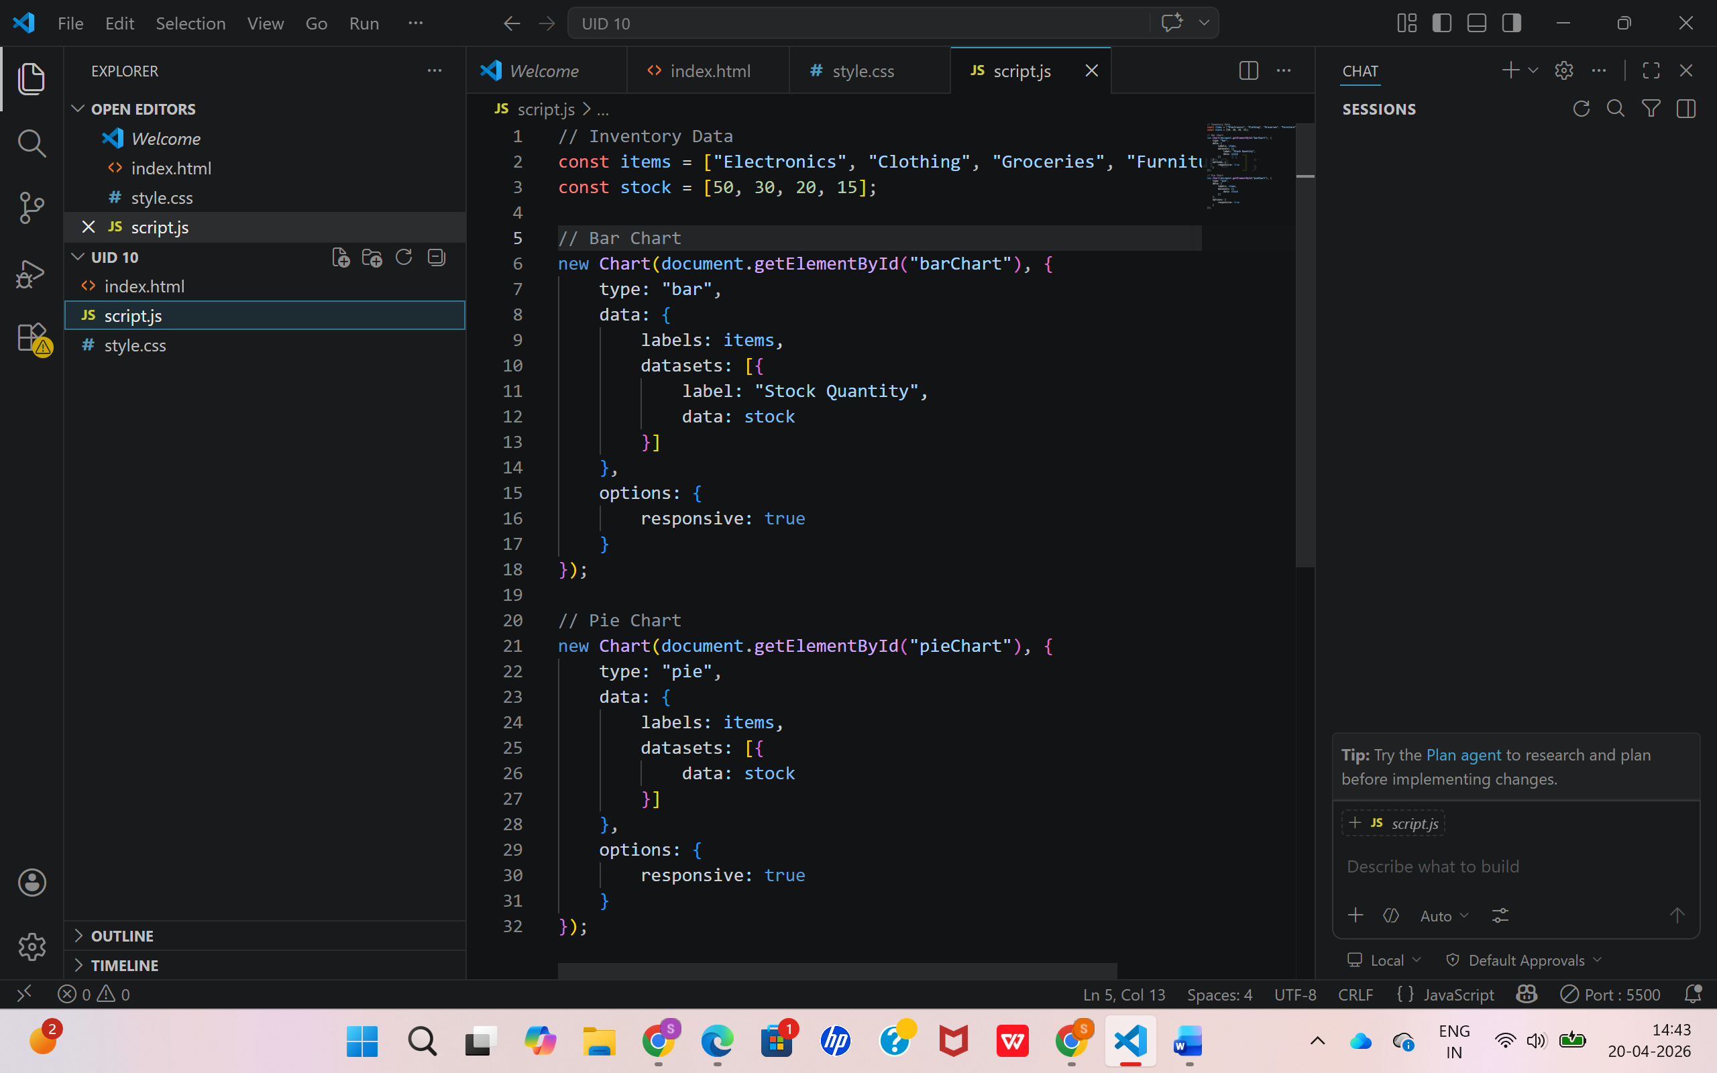

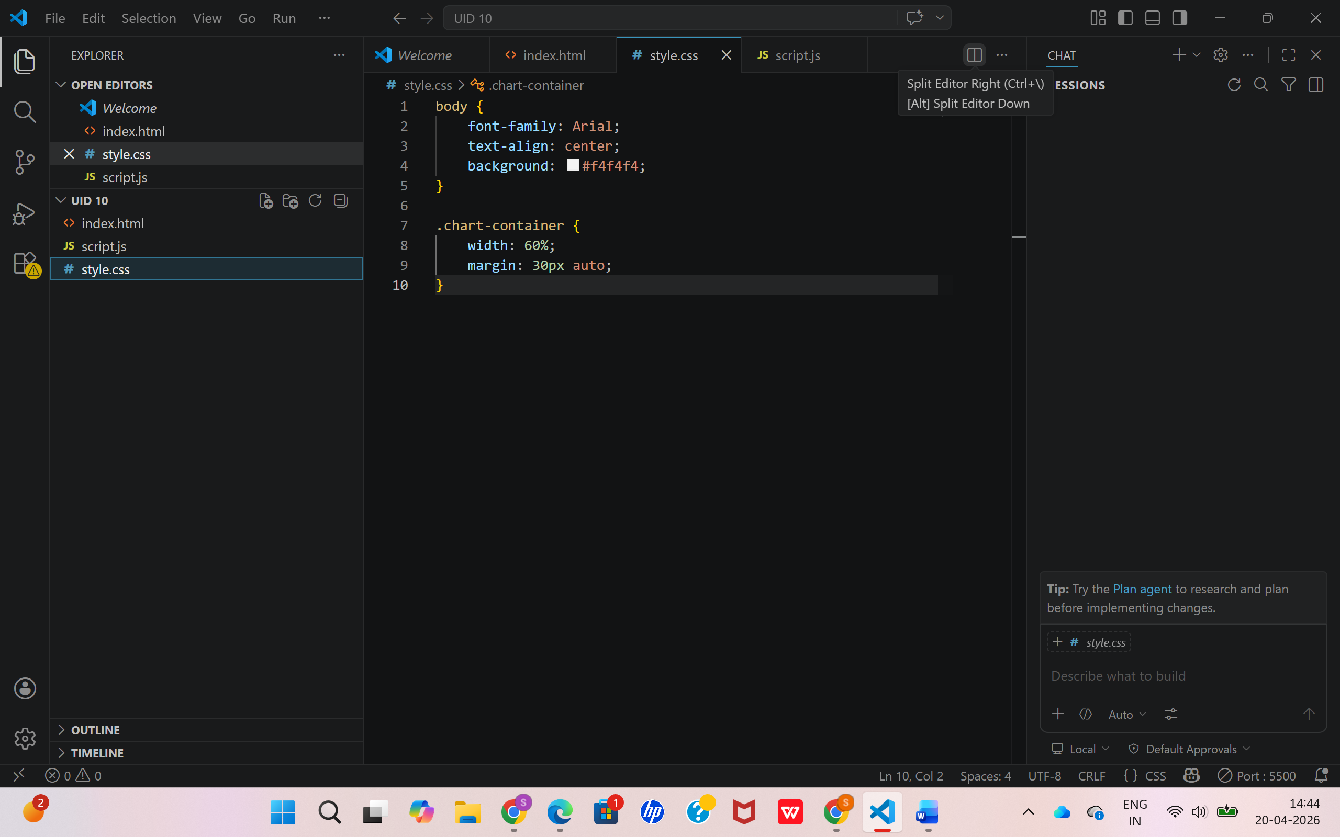
Output
- A webpage displaying:
  - Bar Chart → shows stock comparison of items
  - Pie Chart → shows distribution of inventory

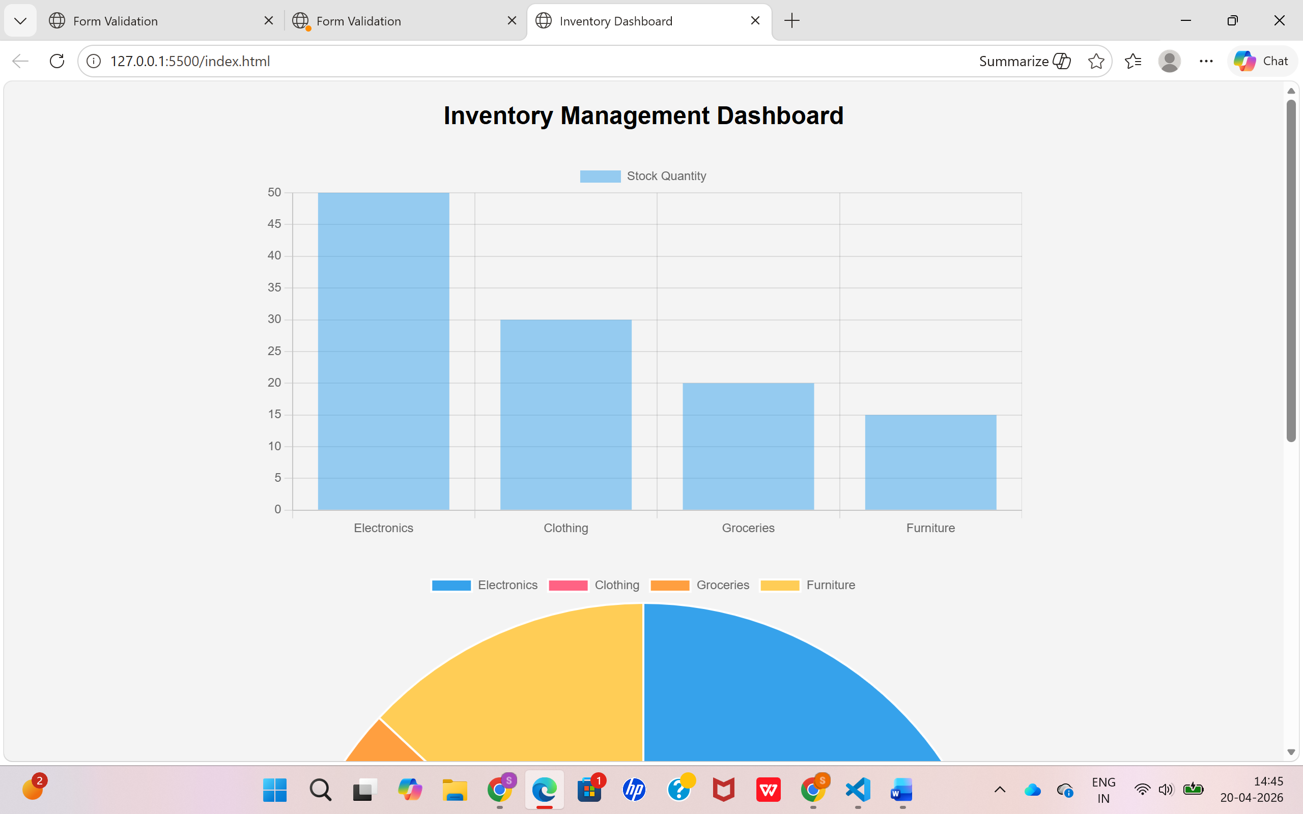

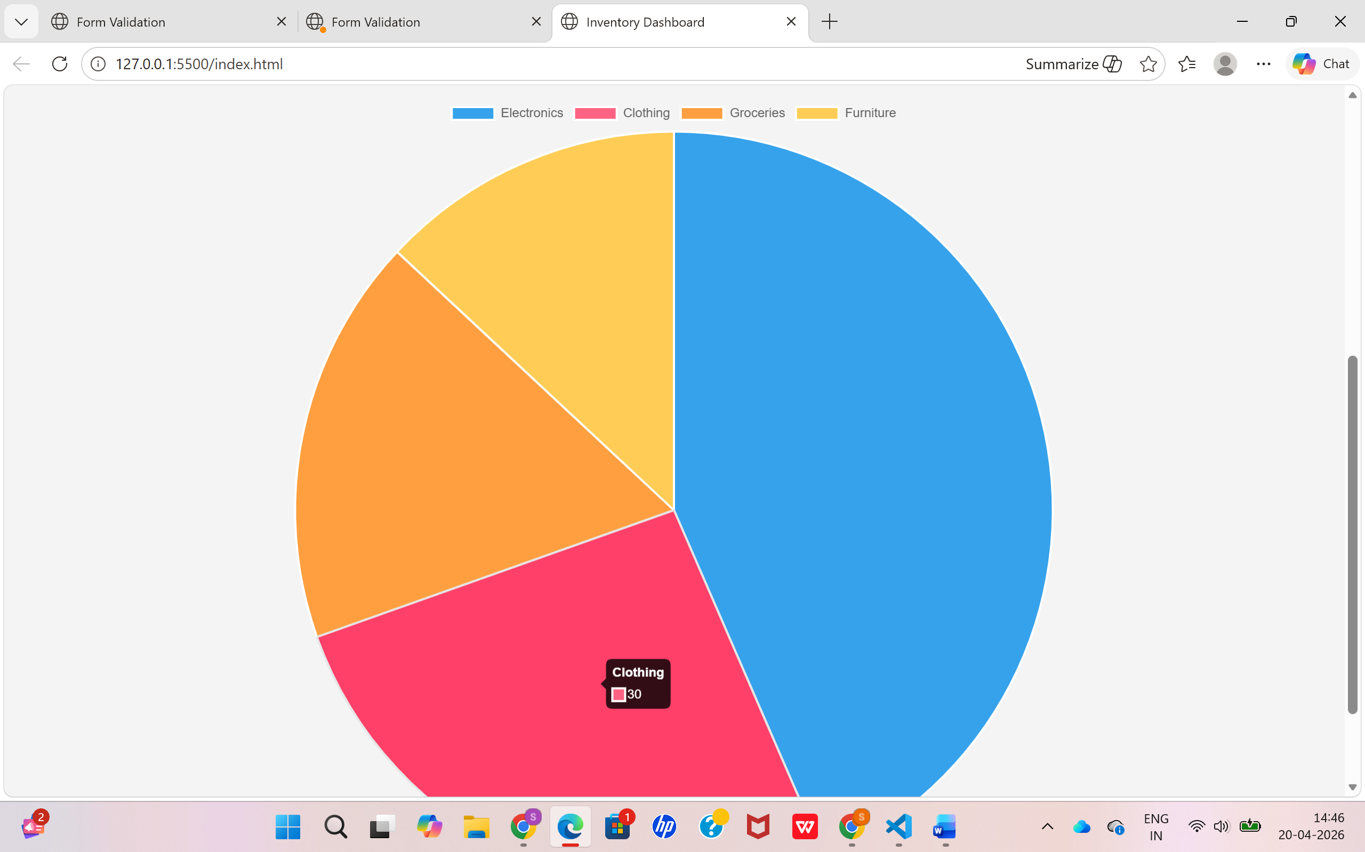
Result
The inventory data was successfully visualized using JavaScript and Chart.js. The bar chart provided a clear comparison of stock quantities, while the pie chart effectively represented the proportional distribution of items.

